2013

Computing Python Tasks

Kenneth Cajigas 4F Mr Littler

Task 1a – Copy and run the following program in python

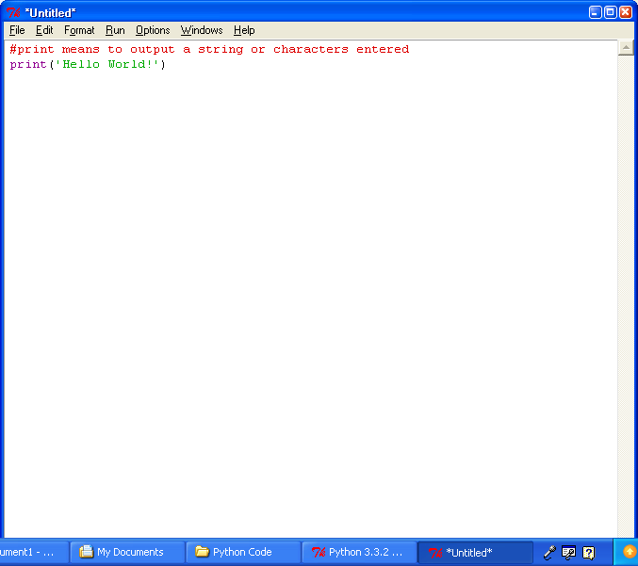

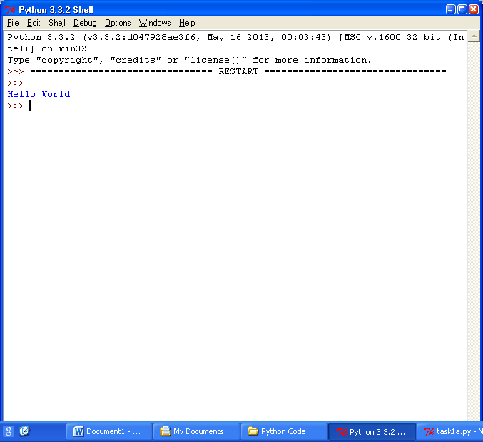

Task 1b – Change the program so it says ‘Pleased to meet you’

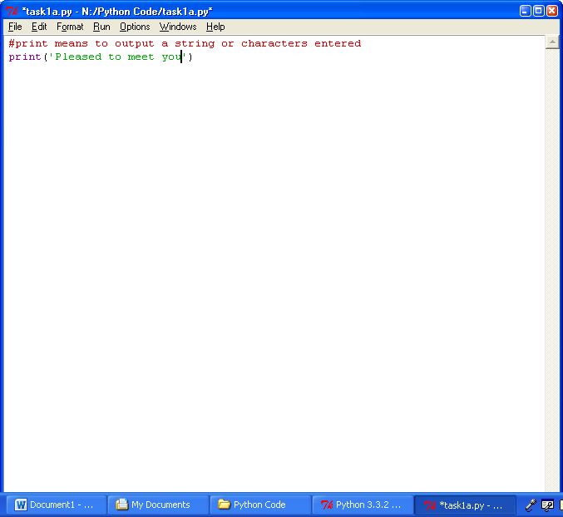

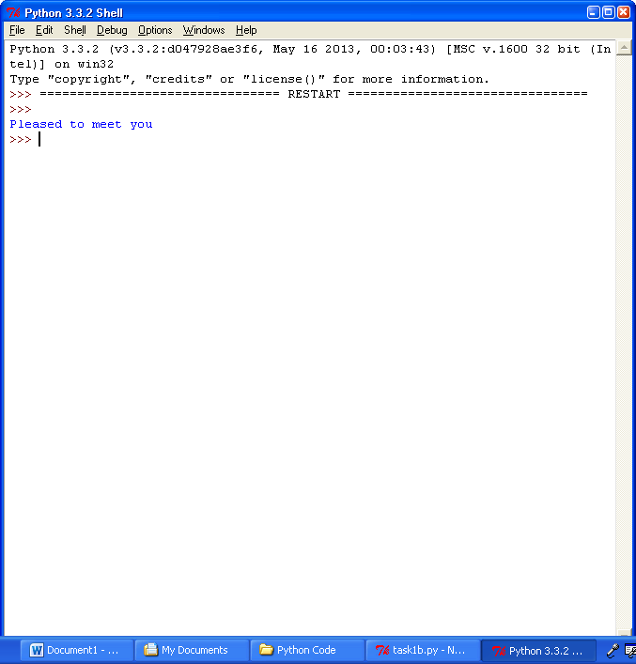

Task 1c – Write the program so it writes on multiple lines

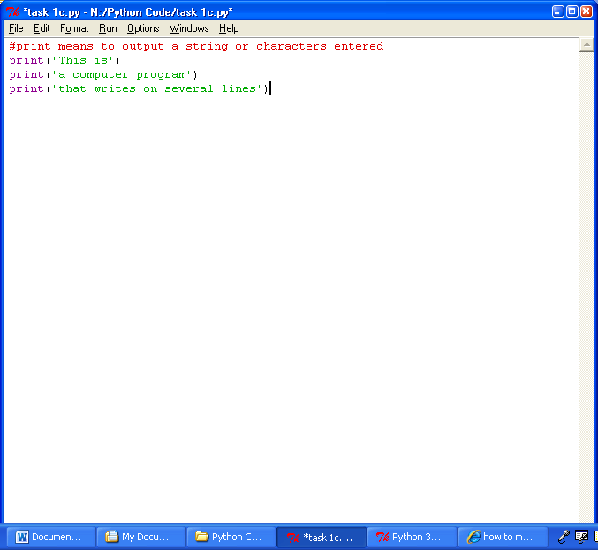

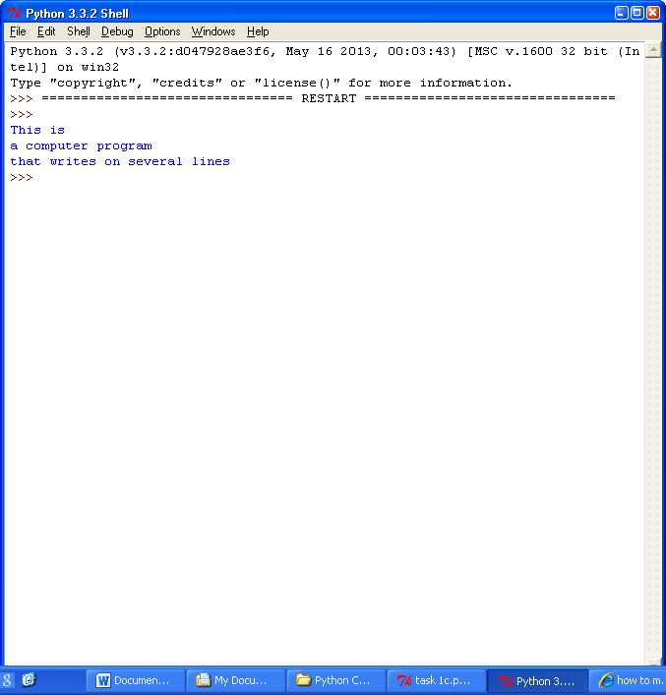

Task 2a – Copy and run the following program

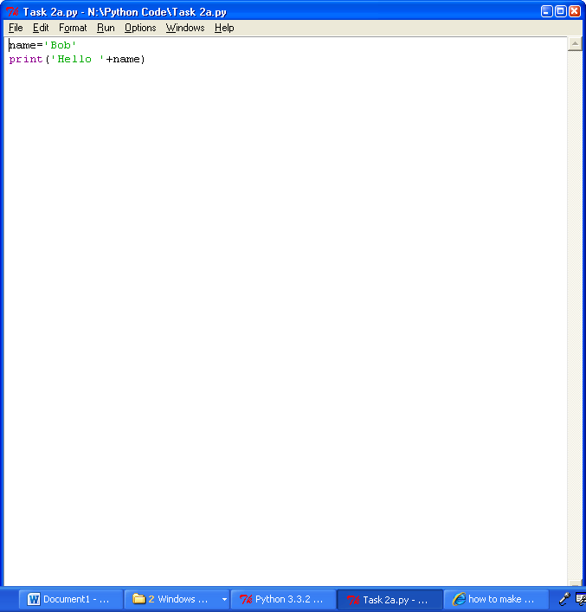

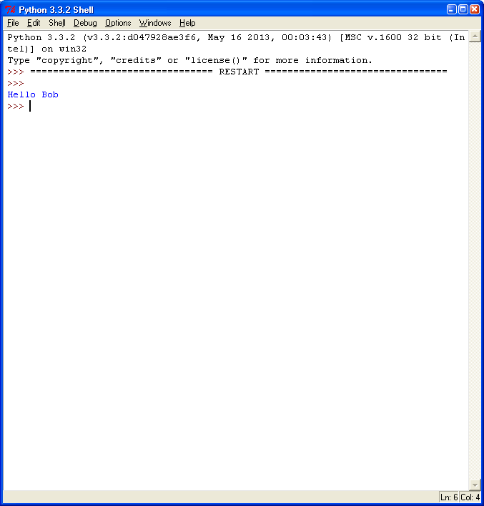

Task 2b – Start a program with:

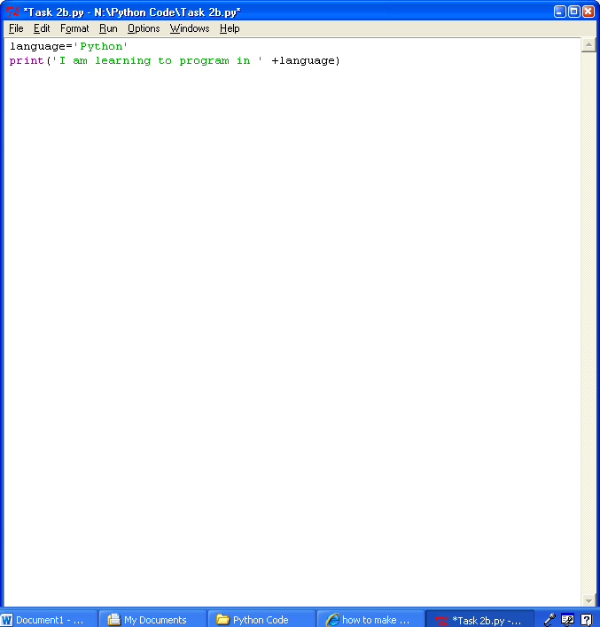

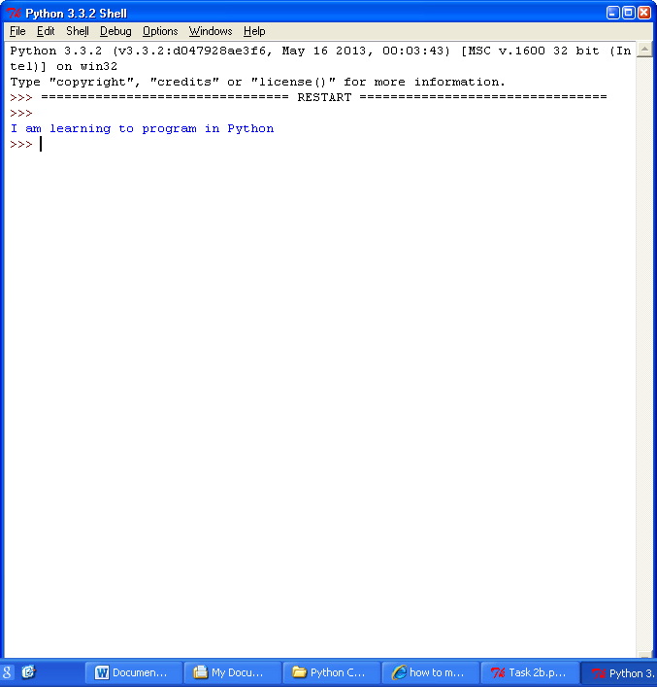

Task 2b (1) -

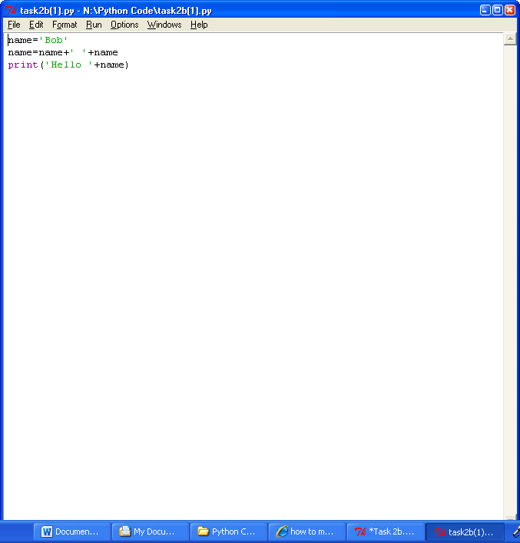

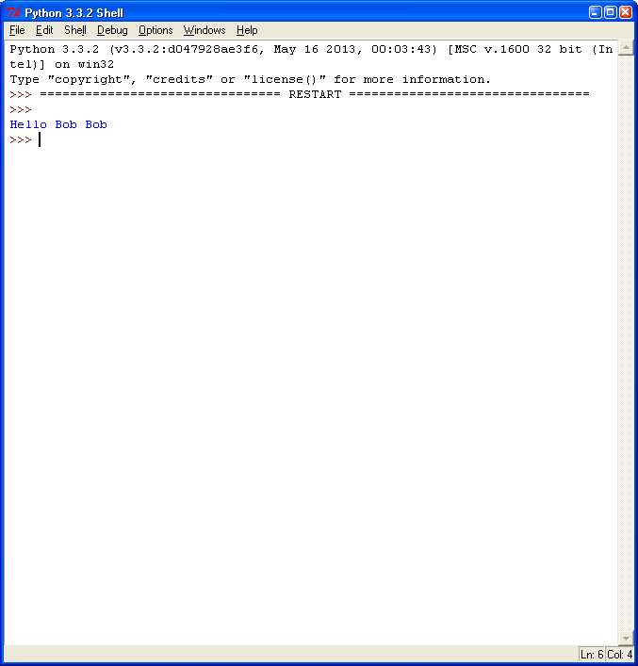

Task 2c – Complete the program so it uses the variables ‘the cat sat on the mat’

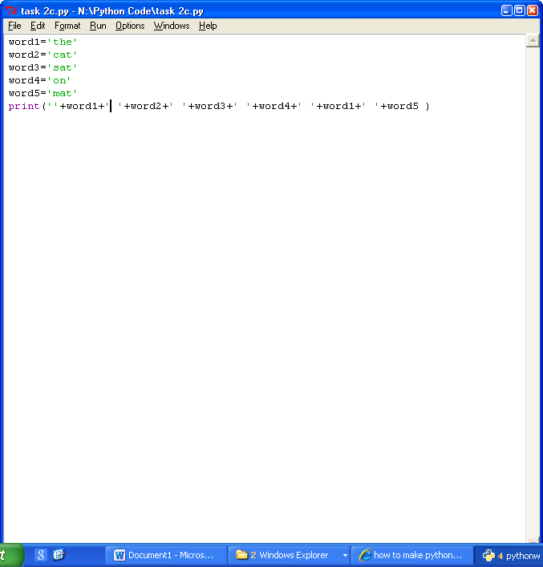

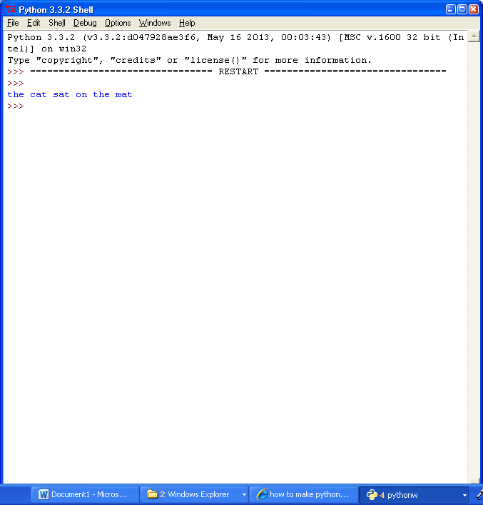

Task3a – Write a program that asks for the town you live in and then replies ‘I love visiting [town]

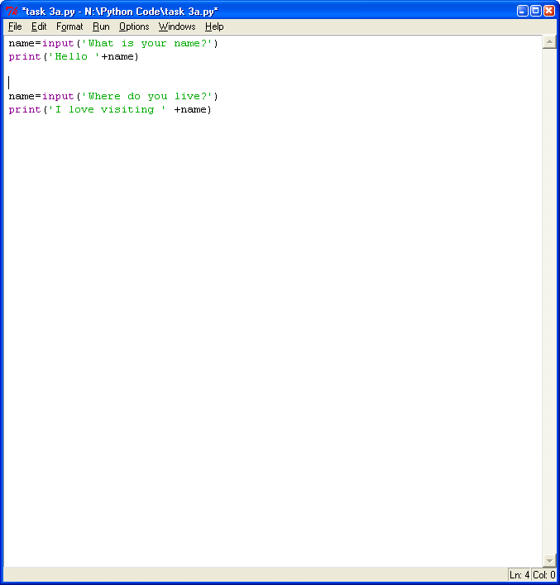

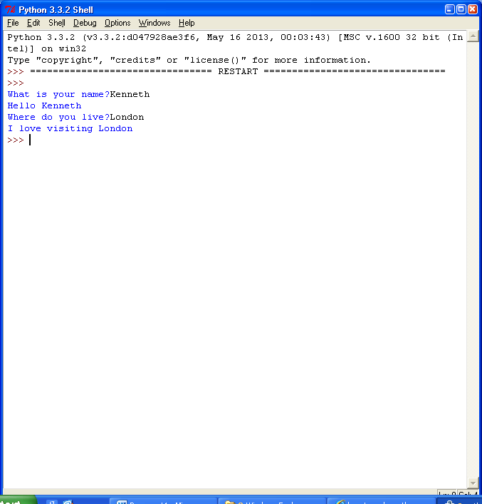

Task 3b – Write a program that asks for your first name, then asks for your last name and finally greets you with your full name

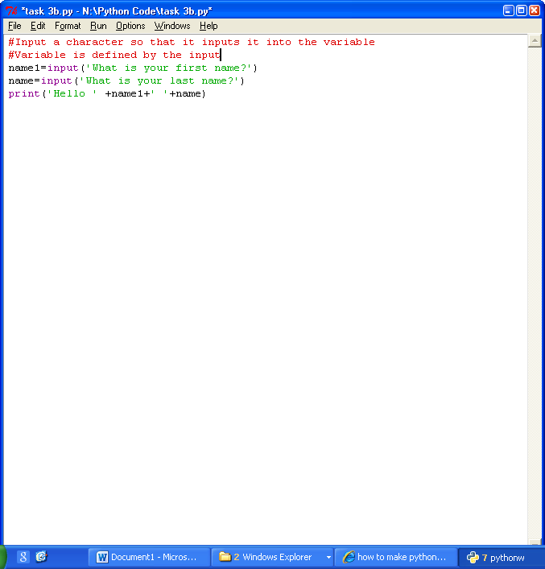

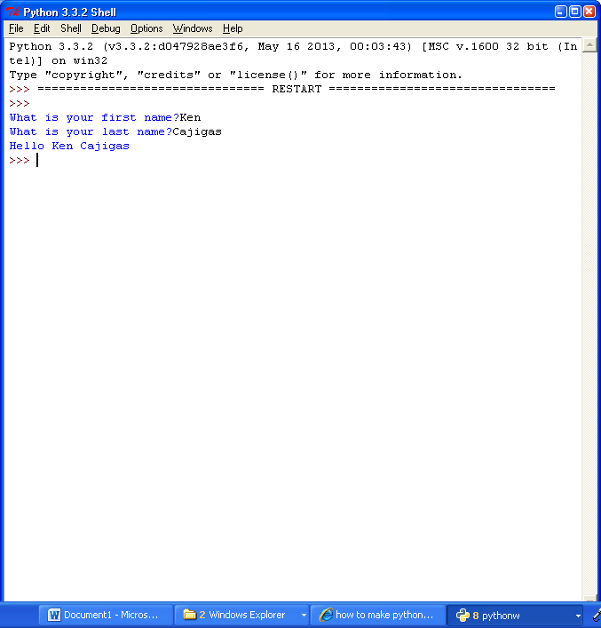

Task 3c – Write a program that asks for your name and then prints it 5 times

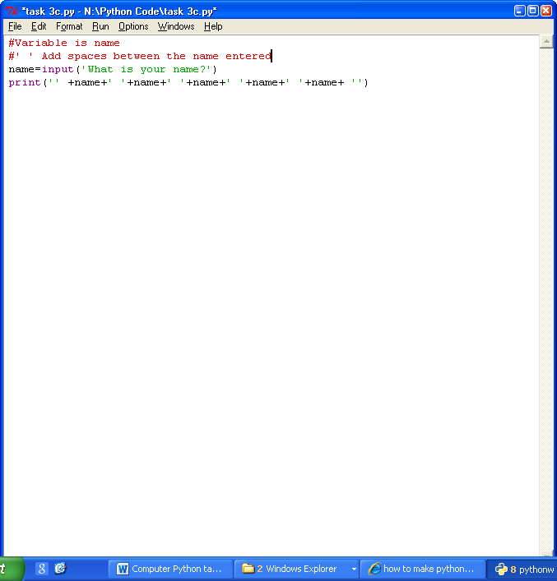

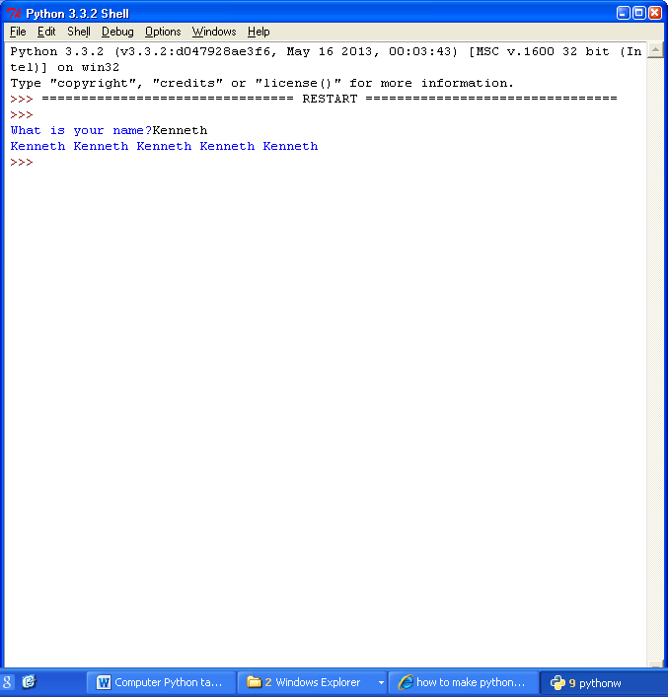

Task 4a – Copy and run the following program

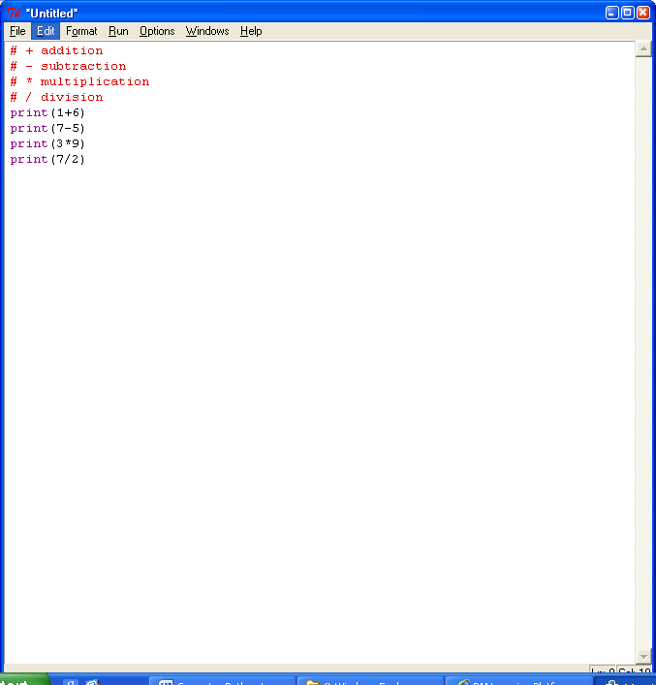

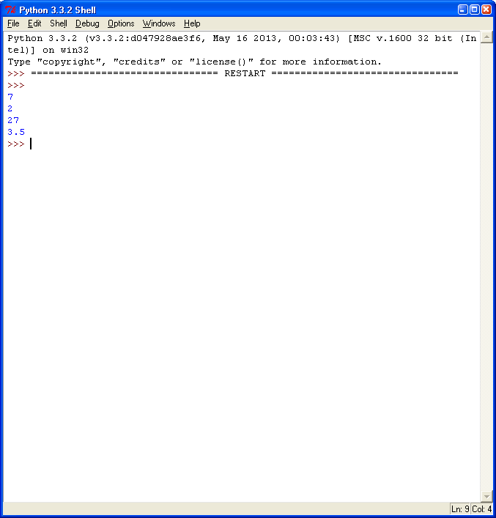

Task 4b- Try changing the calculations to new ones

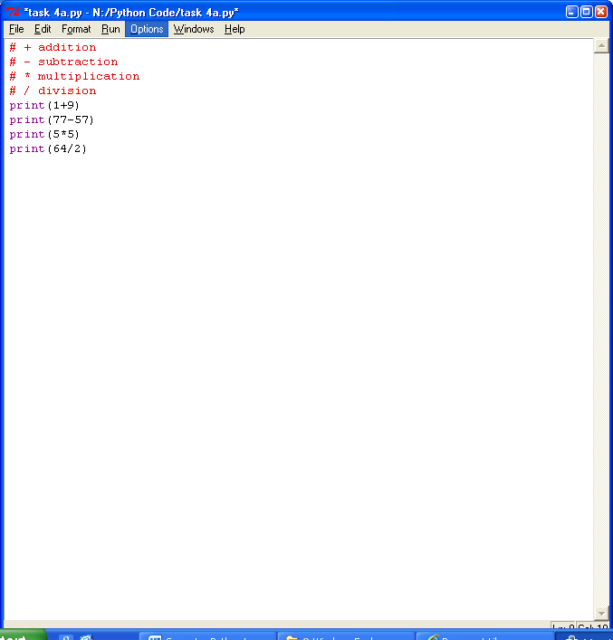

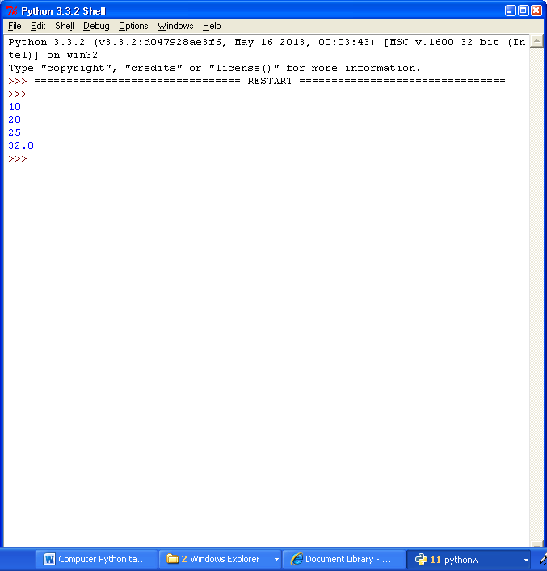

Task 4c – Complete this program so it uses addition on the two variables make c equal to 15 then prints it

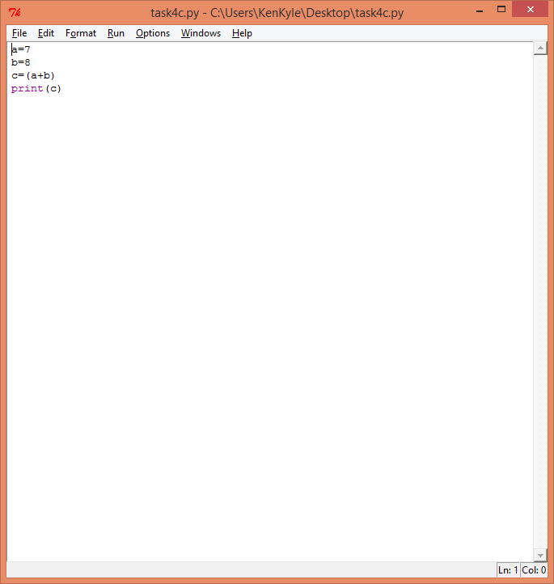

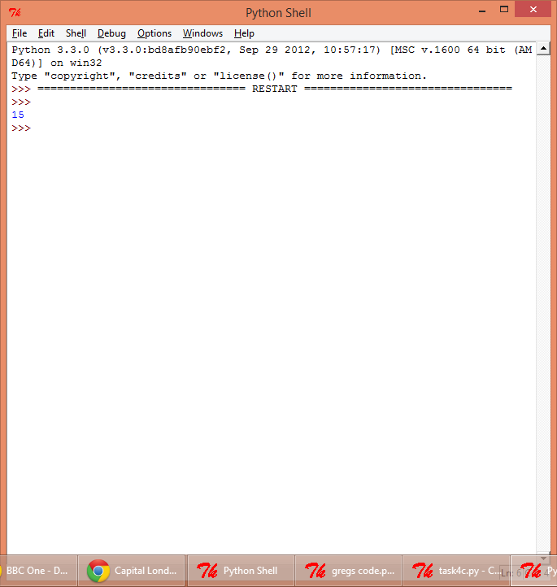

Task 5a – Copy and run the following program:

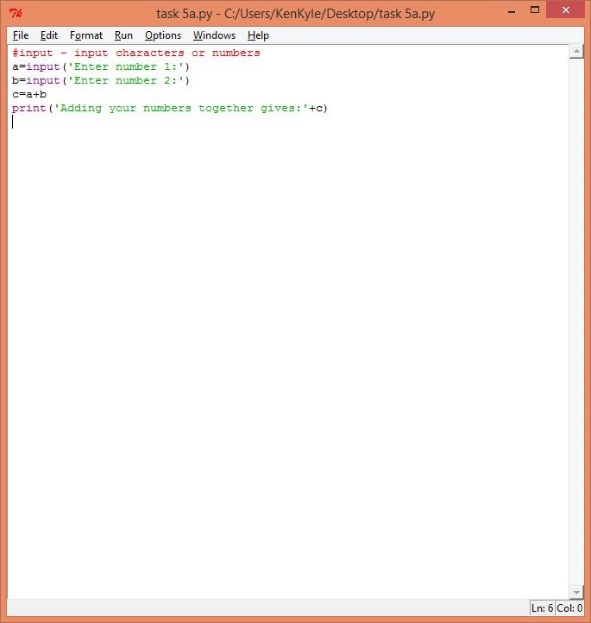

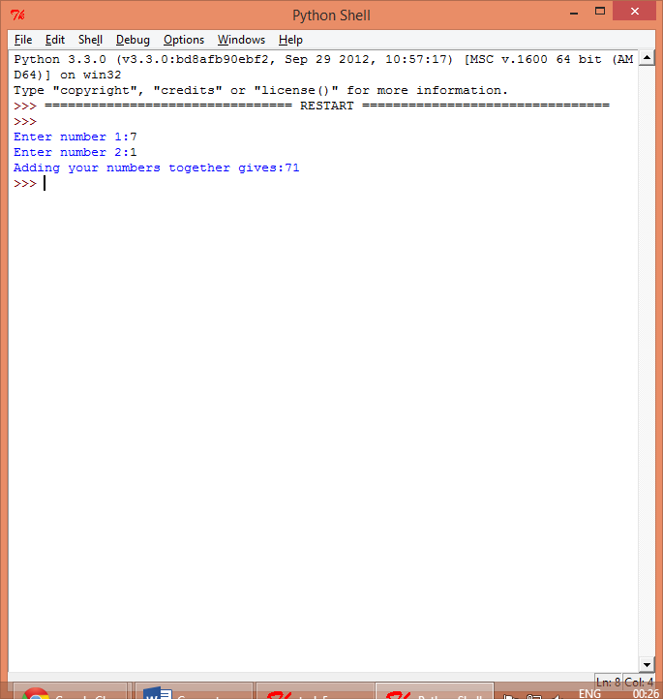

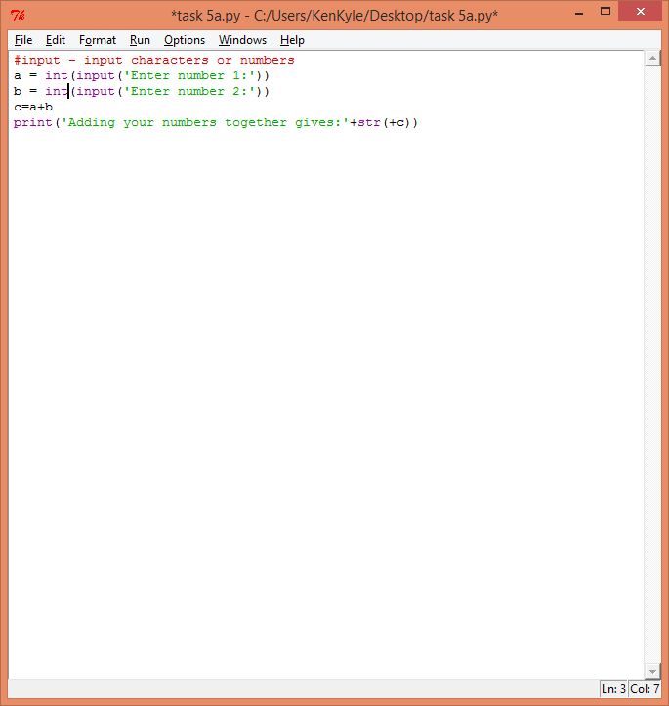

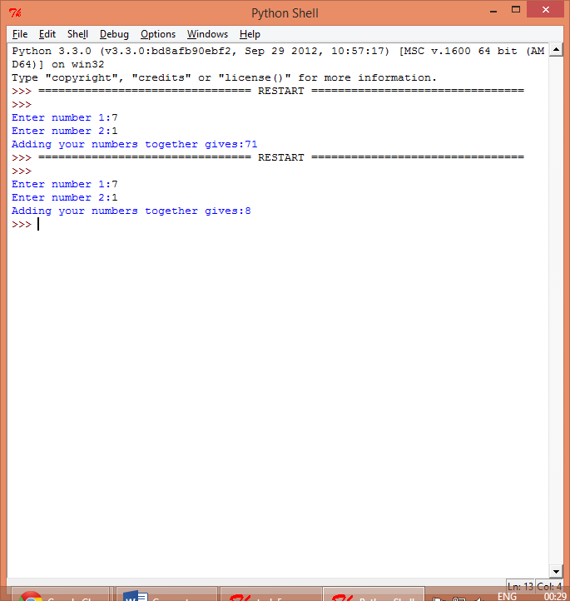

Task 5b – Write a program so it asks for length and width and outputs area of rectangle

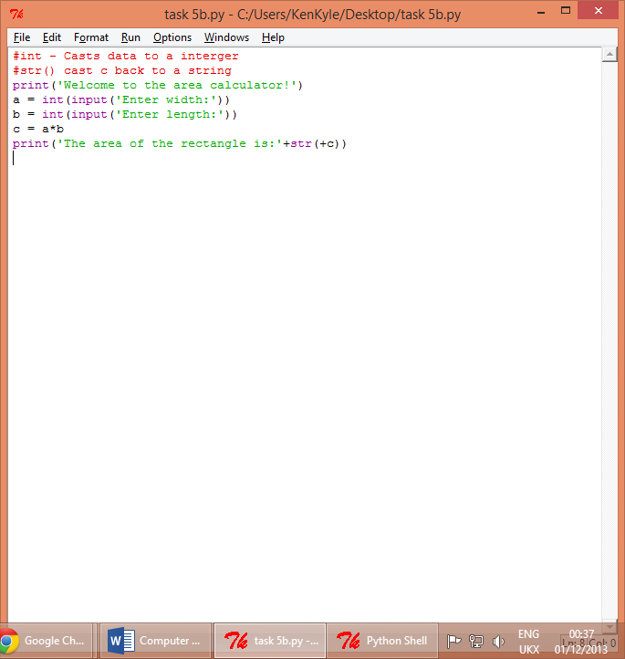

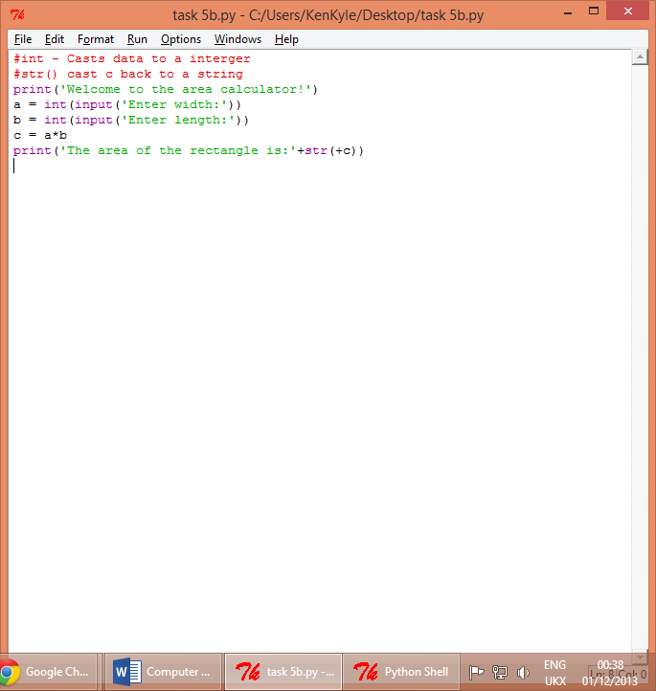

Task 5c –

The formula for the volume of a cylinder is: πr2h

And for its surface area is: 2 πr2+2 πrh

Where r is the radius and h the height. π is the value

3.14159 (5d.p.)

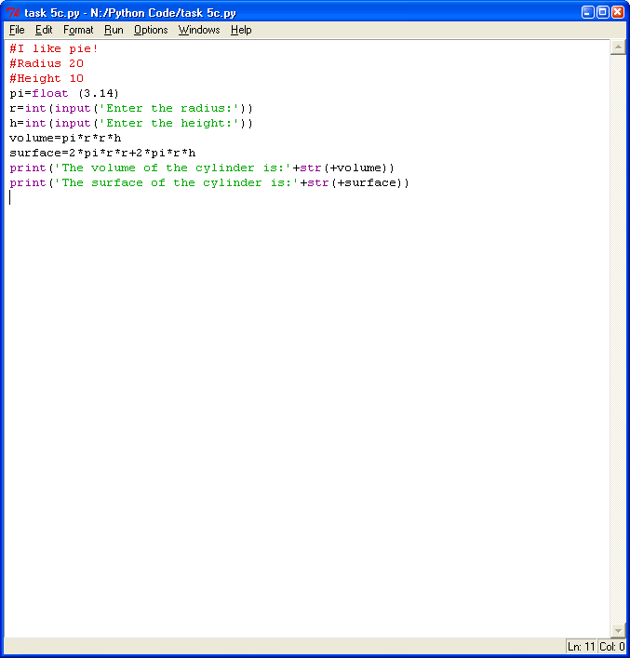

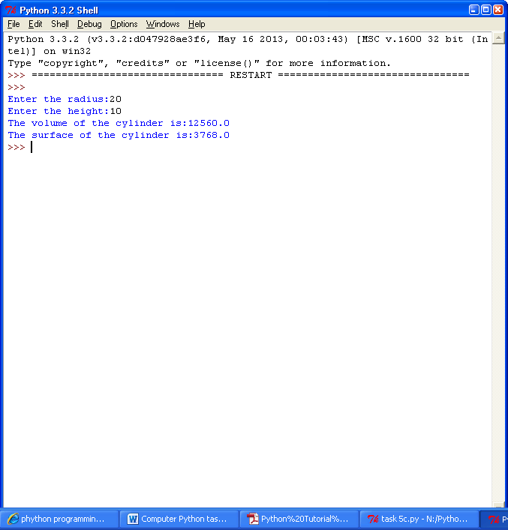

Task 6(1)

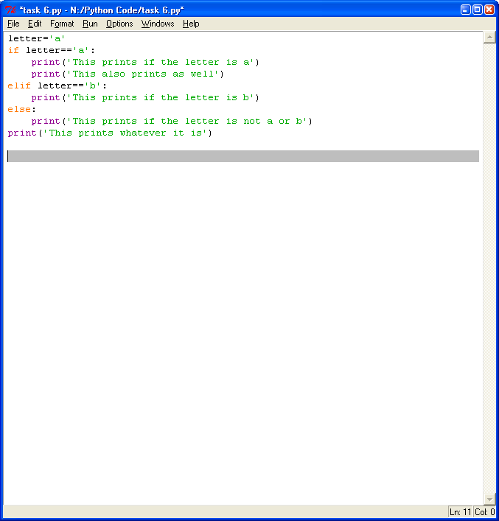

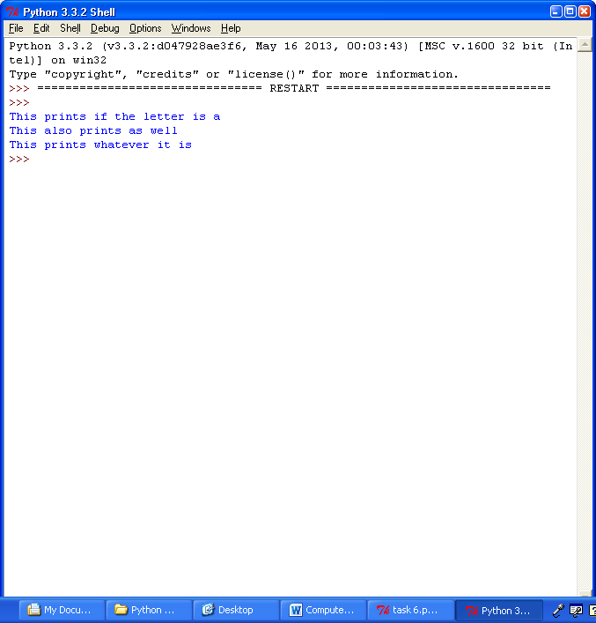

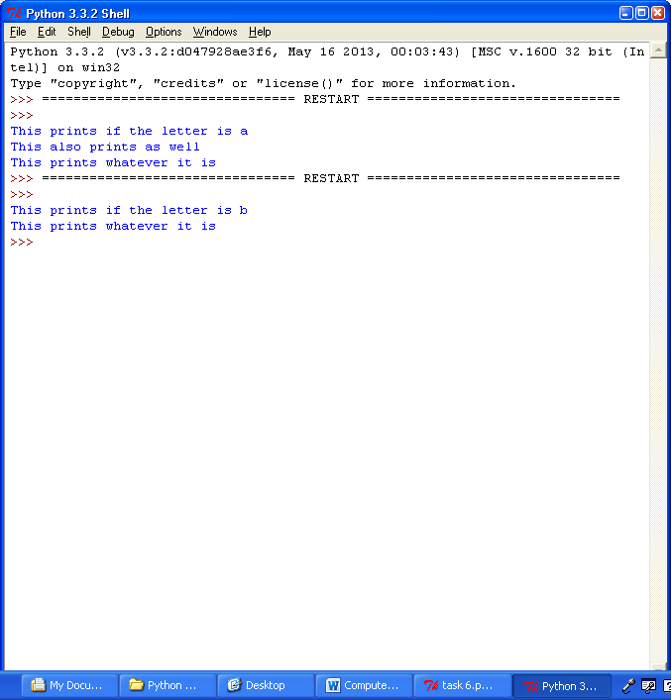

Task 6a – Copy and run the code below:

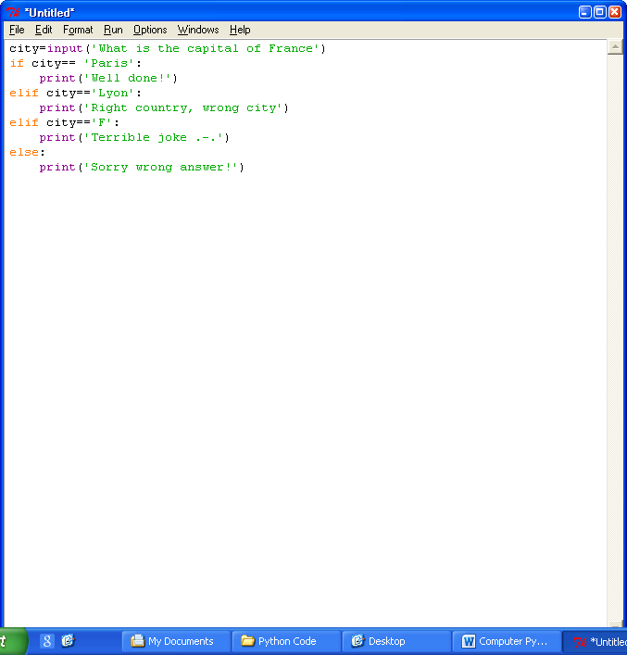

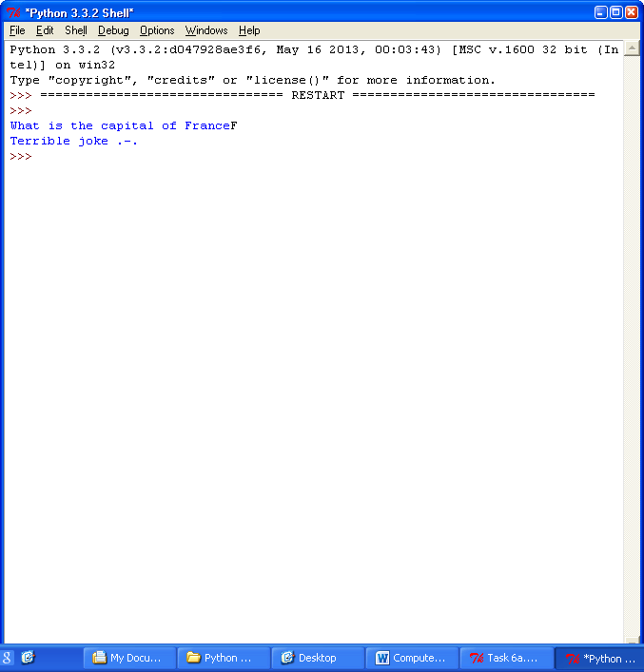

Task 6a(1) – Now change it so it asks for the capital of England

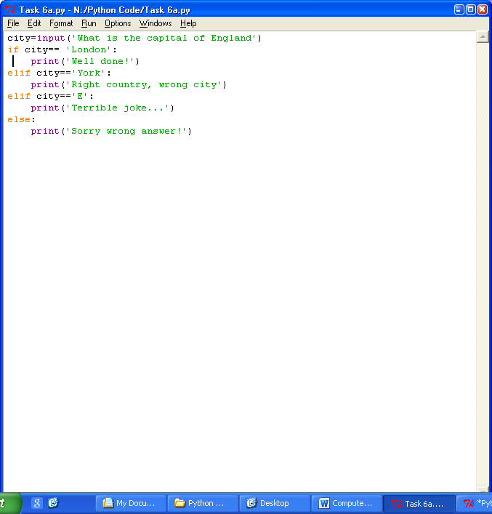

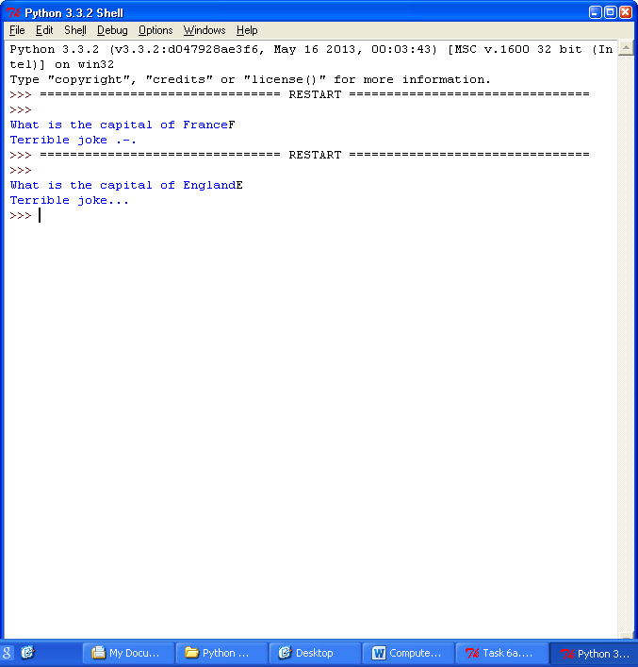

Task 6b – Below is the program that asks for 3 numbers and outputs SNAP if they all match

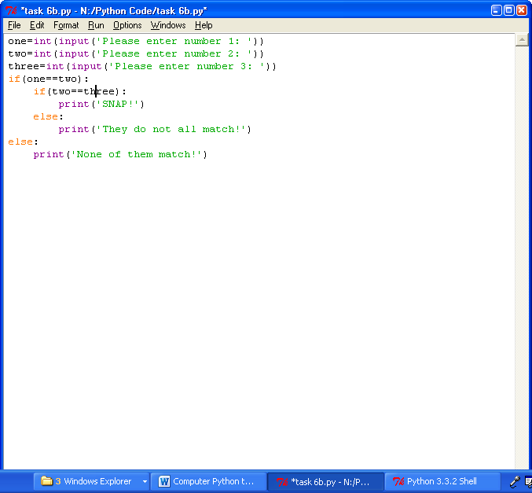

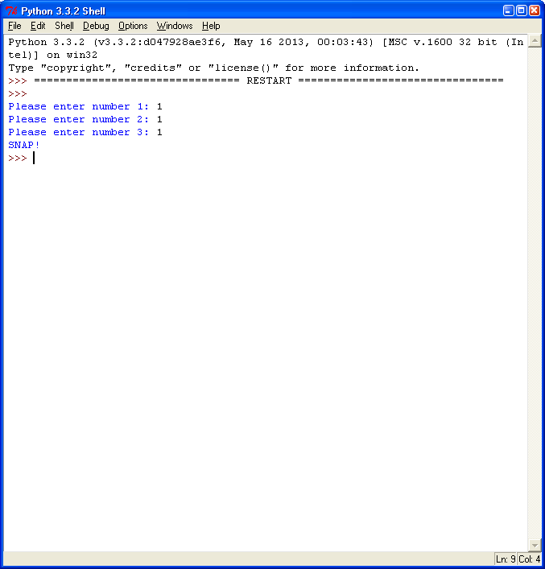

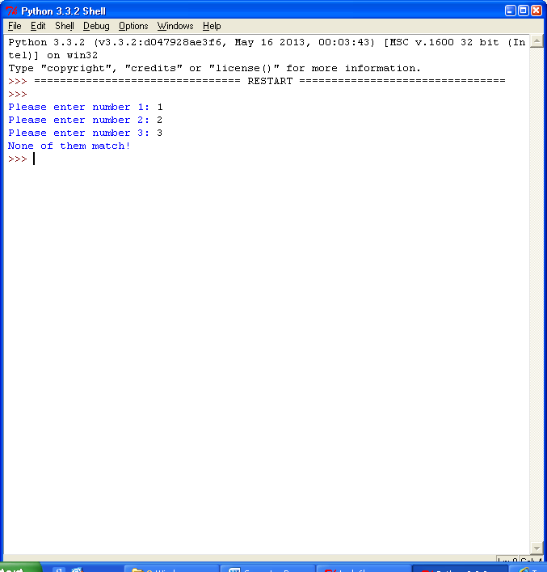

Task 6c – Run a program for the grade boundaries

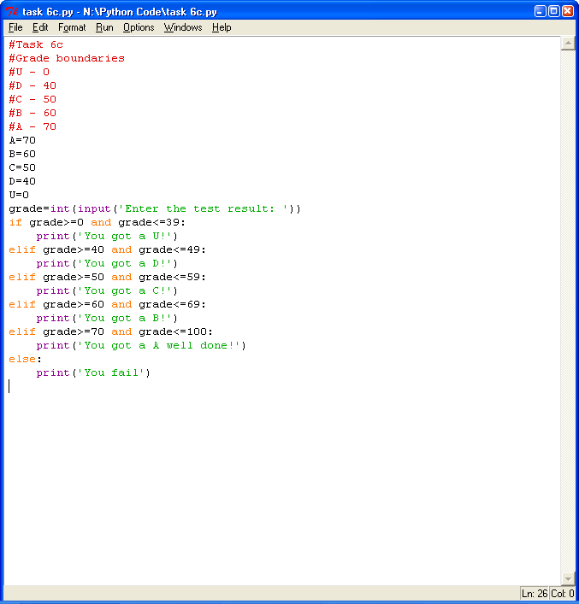

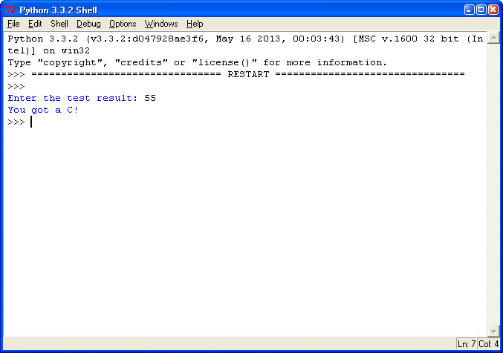

Task 7 – Use comments

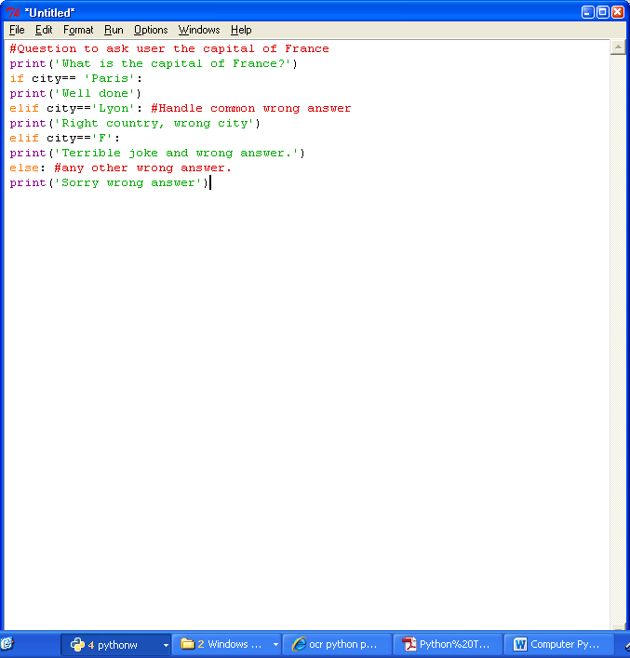

Task 8a – Looping!

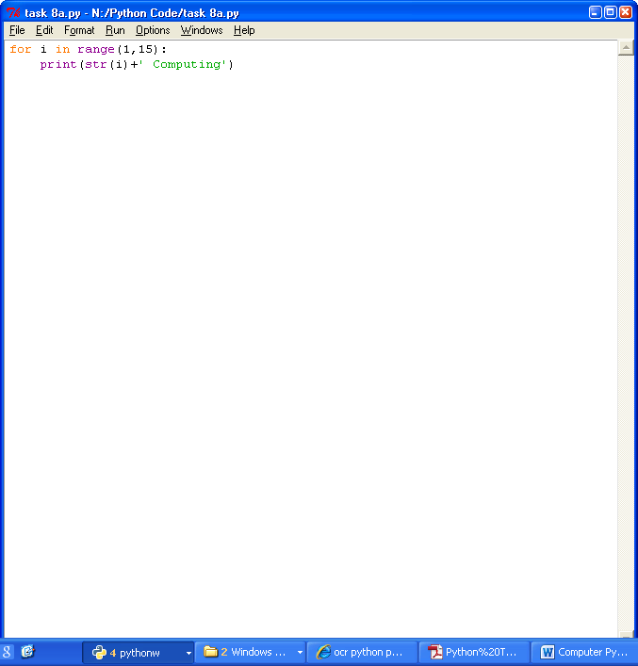

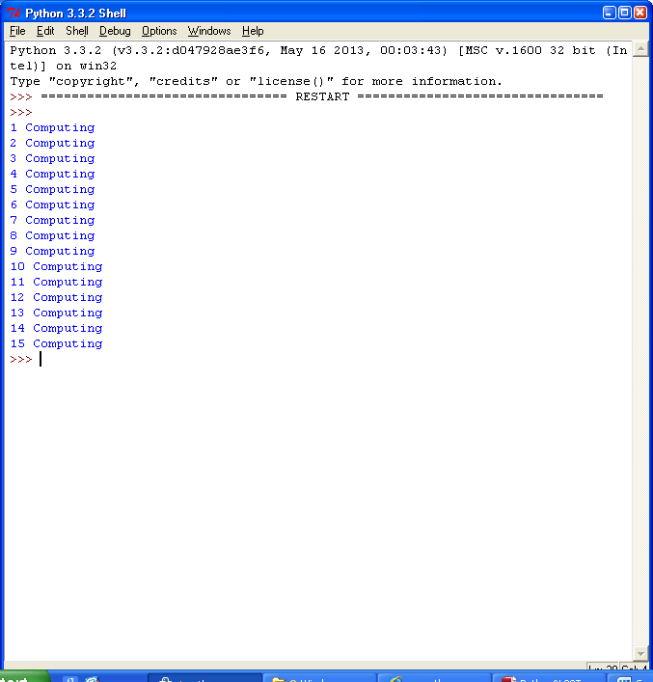

Task 8b - Write a program that takes in a letter and number then prints out that letter that many times.

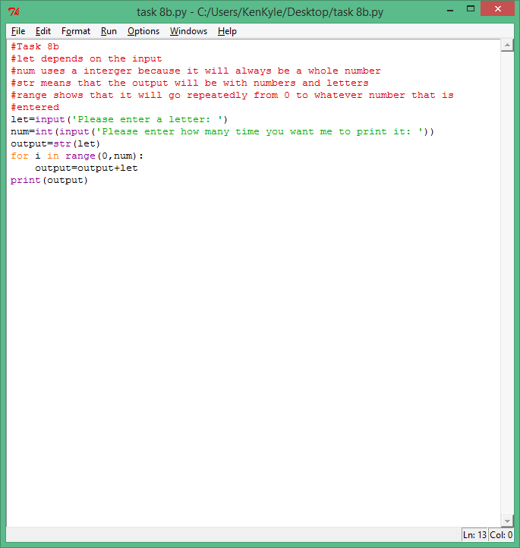

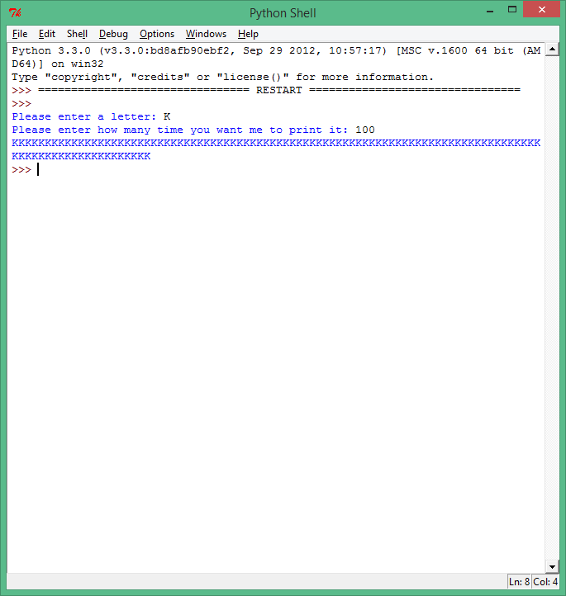

Task 8c - Write a program that asks for a number then outputs it’s 10 times table.

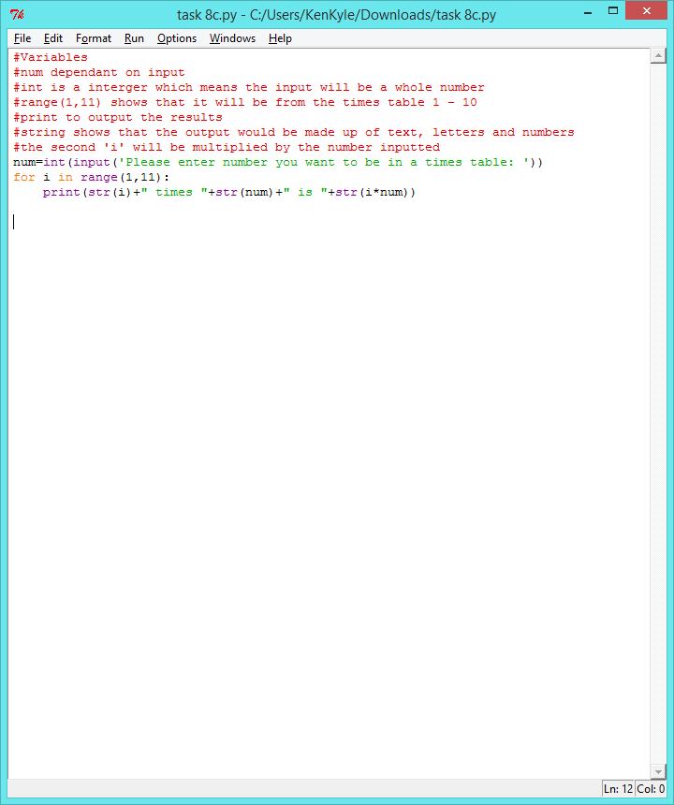

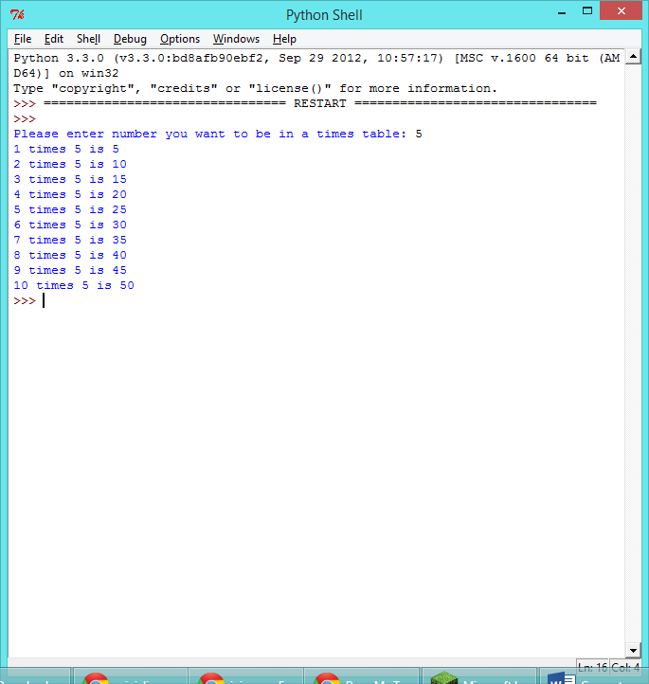

Task 9a - Write a program that asks for a password and keeps asking until the correct password, ‘apple’ is entered and then says Accepted

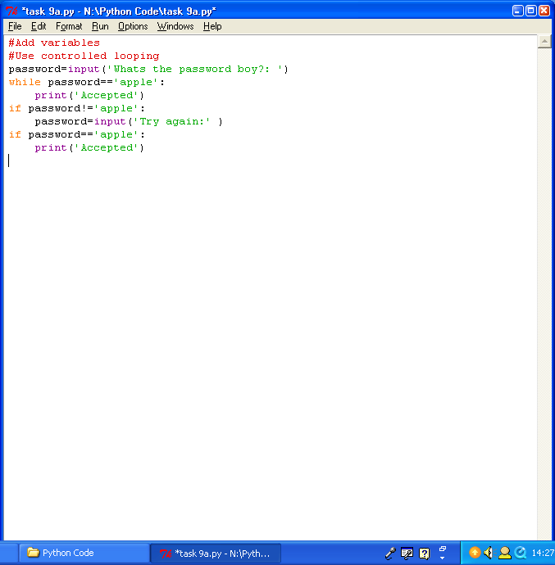

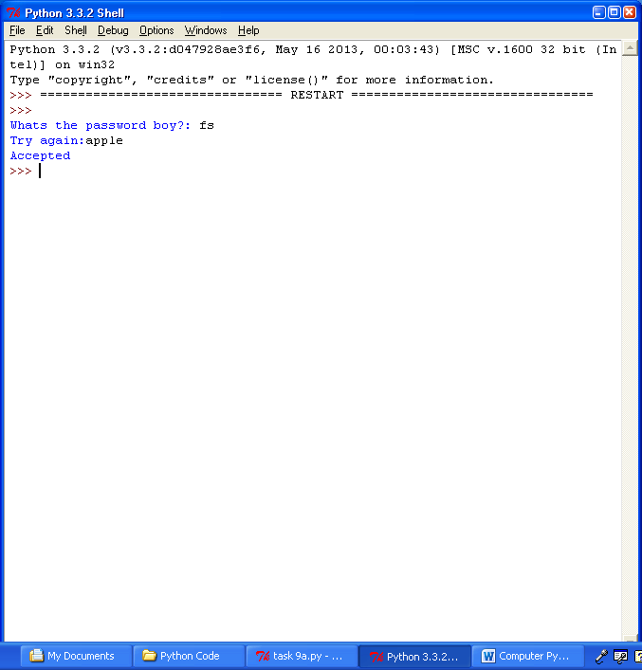

Task 9b – Write a program that prints all the square numbers under 5000

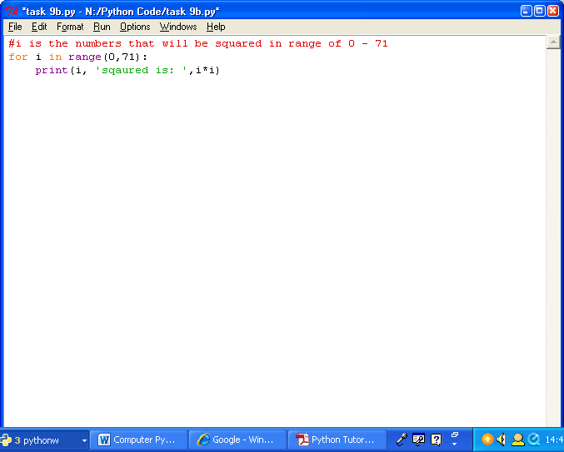

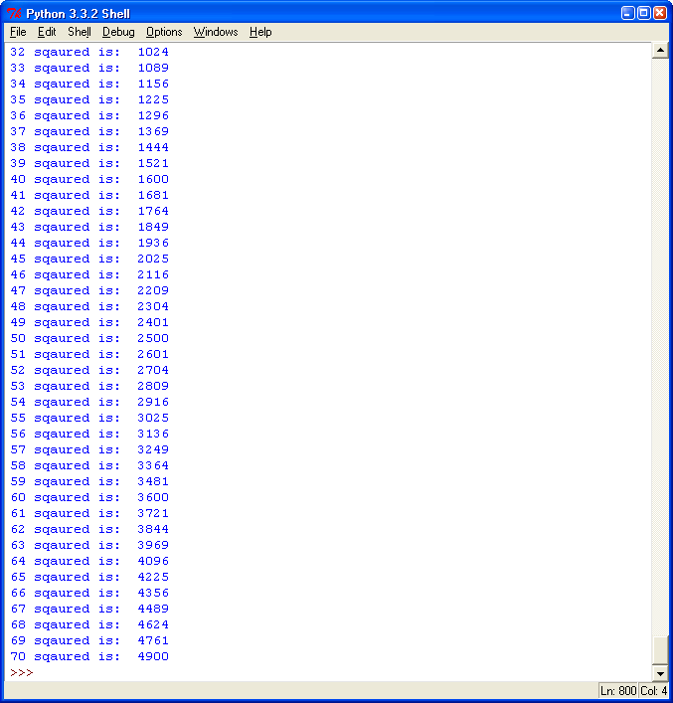

Task 9c - The following code will create an integer x that is a random number between 1 and 100.

Write a program in which the computer thinks of a number between 1 and 100 (i.e. picks a number at random). It should then ask the user to guess what number it is thinking of. It should then say whether the number the computer is thinking of is higher or lower than the one guessed. If the user guess correctly it should say well done and say how many guesses it took them, if not it asks them to guess again.

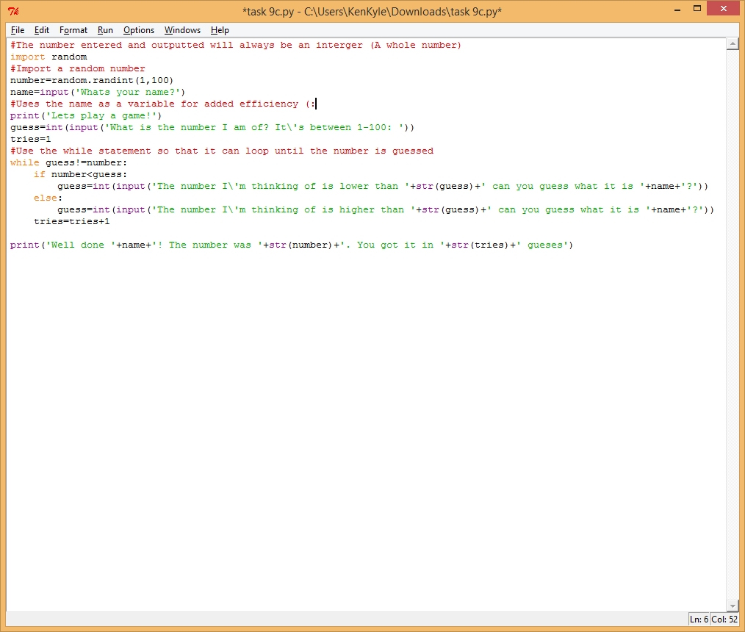

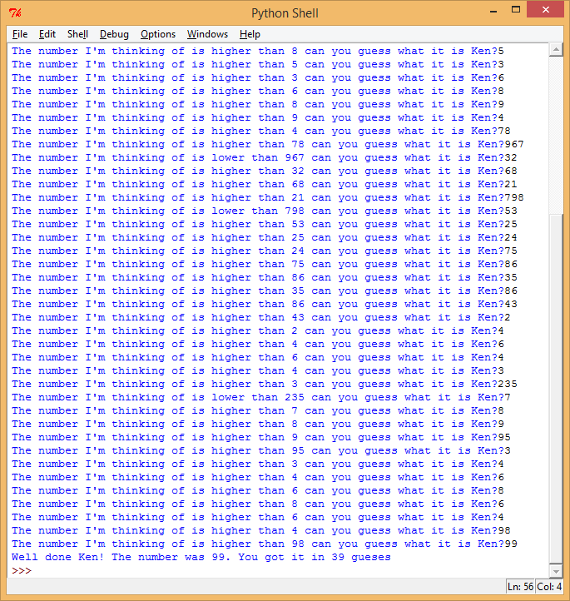

Task 10a - Write a function called circleArea that takes in a float representing the radius and returns the area of a circle.

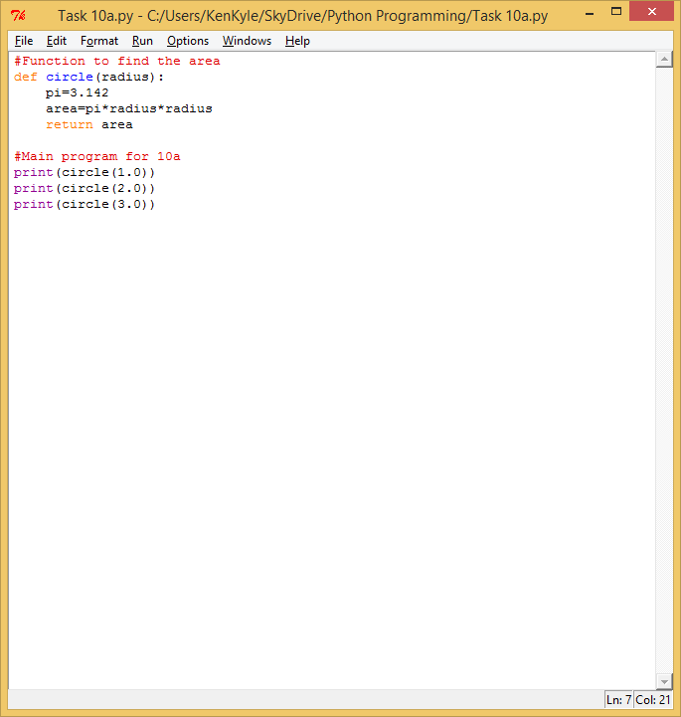

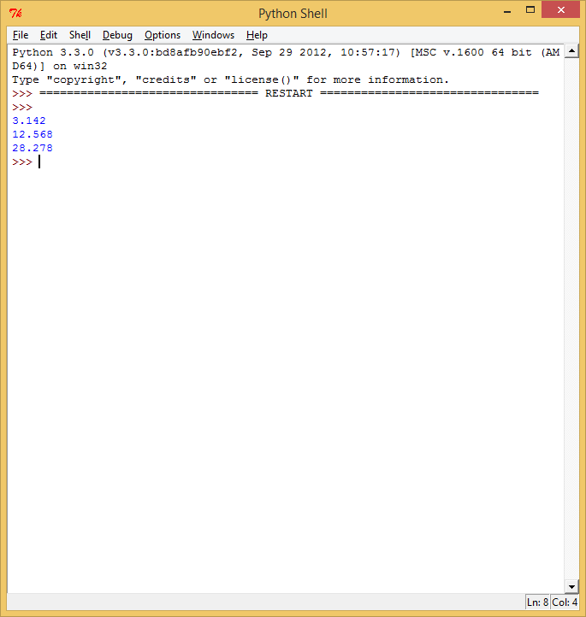

Task 10b - Write a procedure called triangle that takes in a number and then prints out a triangle of that height.

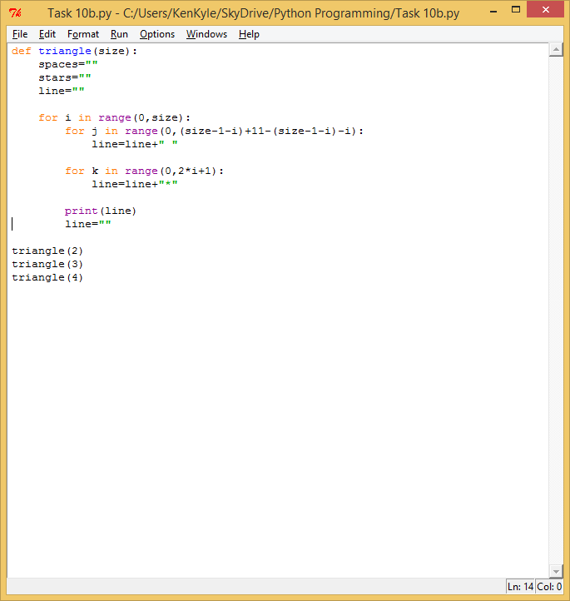

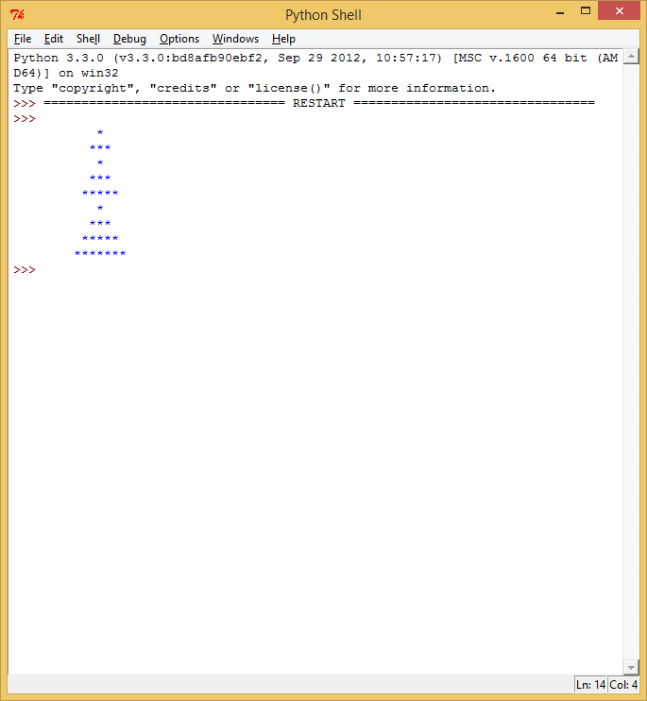

Task 11a – Write a program that keeps asking for names until the word END is entered at which point it prints out the list of names.

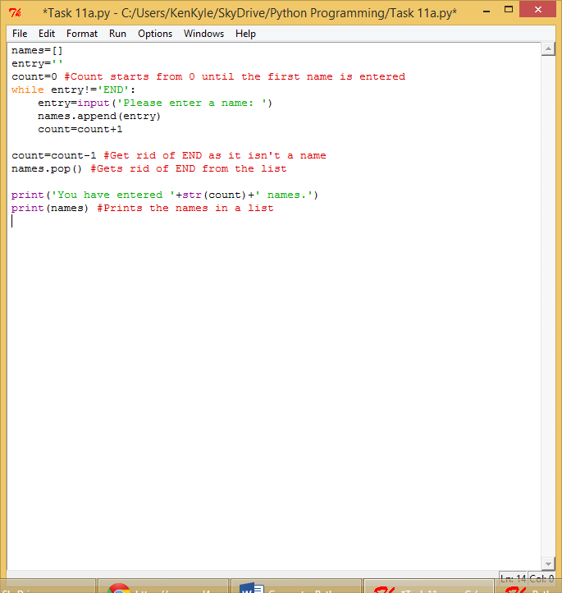

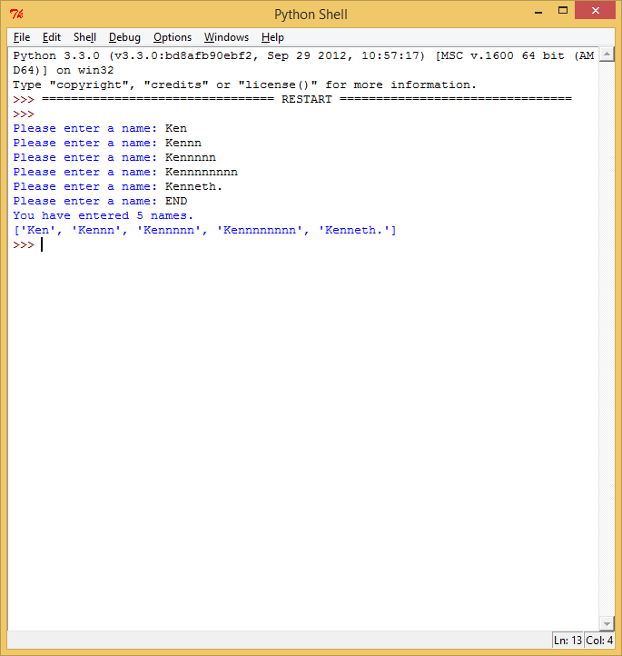

Task 11b – Write a program that asks the user to enter 5 names which it stores in a list. Next, get it to

pick one of these names at random and declare that person as the winner.

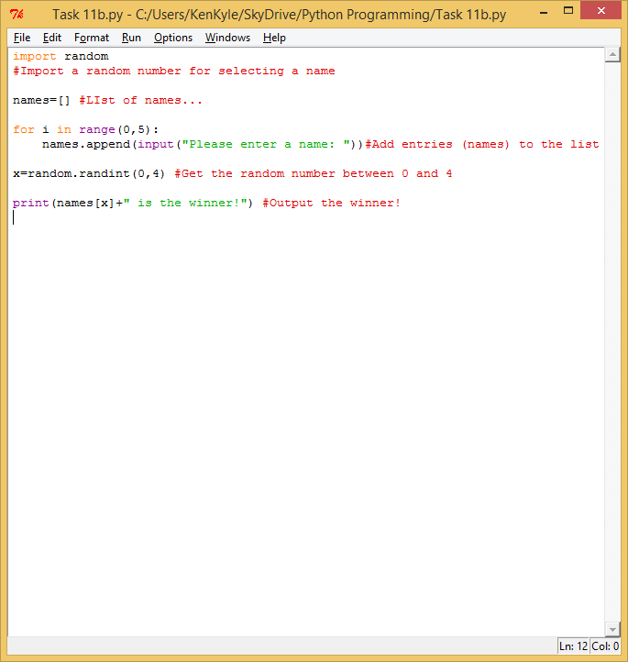

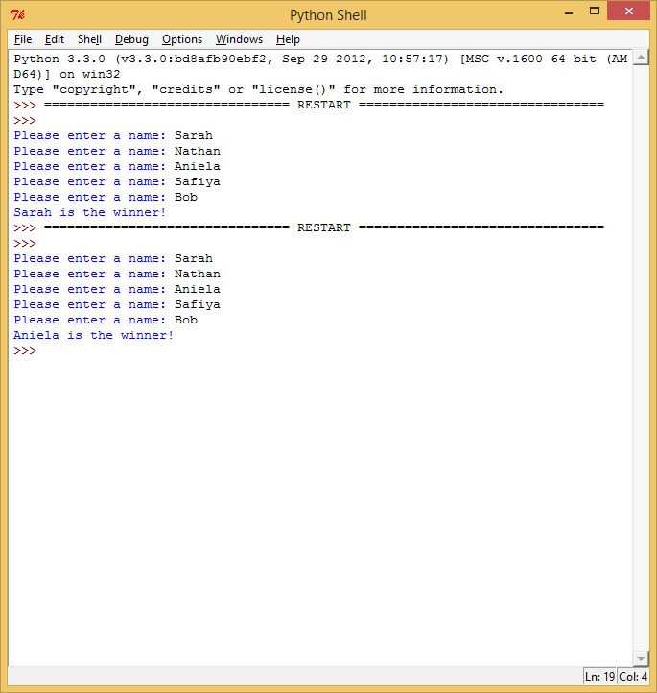

Task 11c - Write a program that prints out all the primes below 10,000

Very complex for me big boy :/

Task 12a –

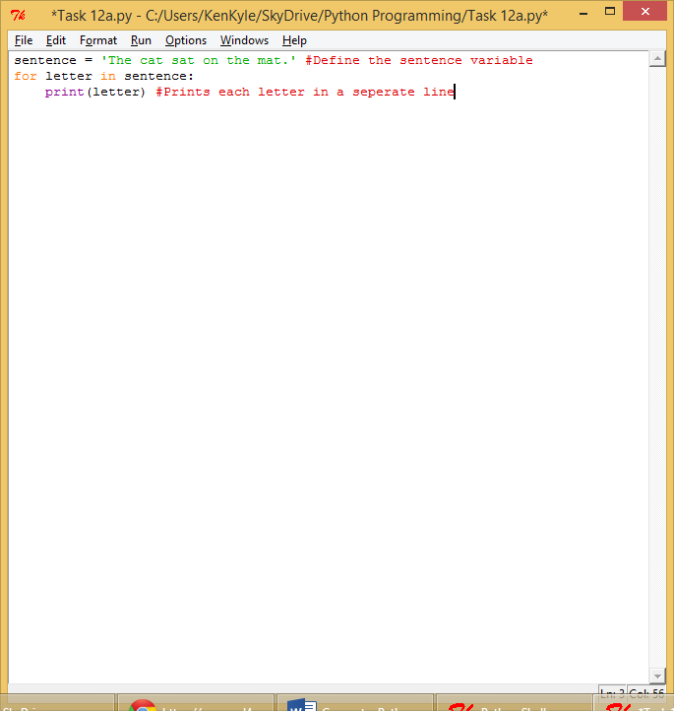

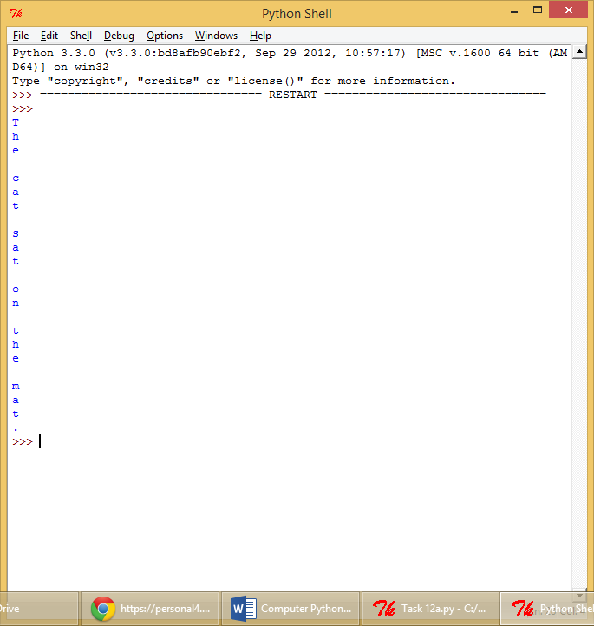

Task 12b – Change the previous program so it counts the number of occurrences of the lowercase letter a.

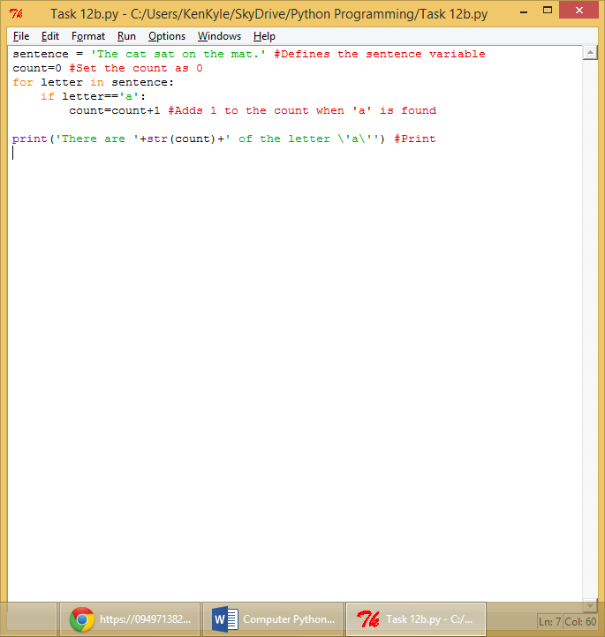

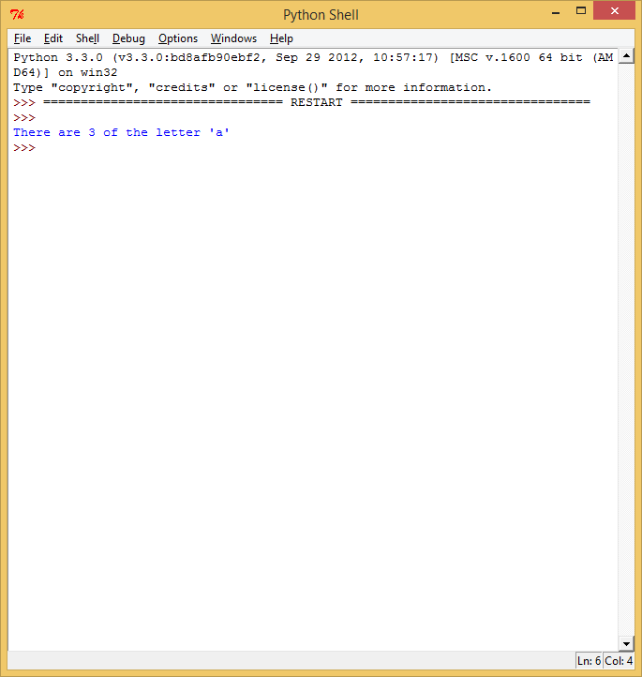

Task 12c – To be done…